Random Forest & KNN

Objective:

Predict a window machine’s probability of getting infected by various families of Malware based on the machine’s various properties.

Determine the factors that put windows machines at risk.

Build random forest model and tune parameters:

**Input:** 35 variables including HasDetections (factor), 10000 records

HasDetections: 0 1

49844 50156

**Output:** model1(called rf 1), all parameters are by default.

randomForest (formula = HasDetections ~ ., data = train)

Type of random forest: classification

Number of trees: 500

No. of variables tried at each split: 5

OOB estimate of error rate: 21.91%

Confusion matrix:

0 1 class.error

0 38669 11175 0.2241995

1 10730 39426 0.2139325

**Prediction by model1**

--Training dataset: Accuracy: 1

Confusion Matrix and Statistics

Reference

Prediction 0 1

0 49844 0

1 0 50156

--Testing dataset: Accuracy: 0.5933

Confusion Matrix and Statistics

Reference

Prediction 0 1

0 29064 19717

1. 20955 30264

Tune parameters:

--Look for best number of trees by plot

Select n.tree= 500

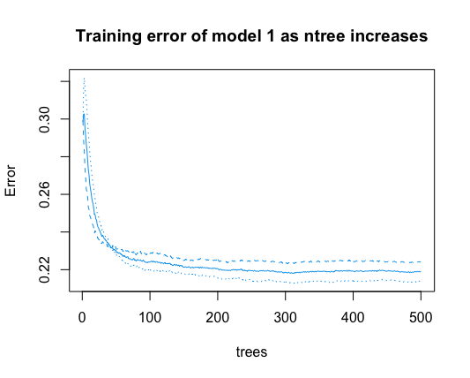

--Look for best mtry by plot

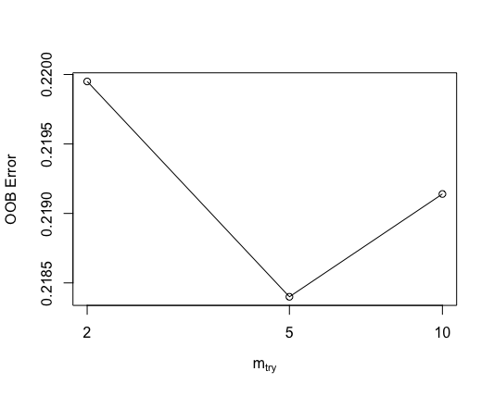

--Distribution of nodes

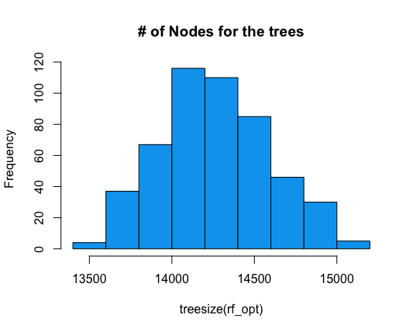

**Check parameters to refit the model – default is best**

Training

Confusion Matrix and Statistics: Accuracy : 1

Reference

Prediction 0 1

0 49844 0

1 0 50156

Confusion Matrix and Statistics: Accuracy : 0.5933

Reference

Prediction 0 1

0 29051 19705

1 20968 30276

Importance of variables:



Frequency

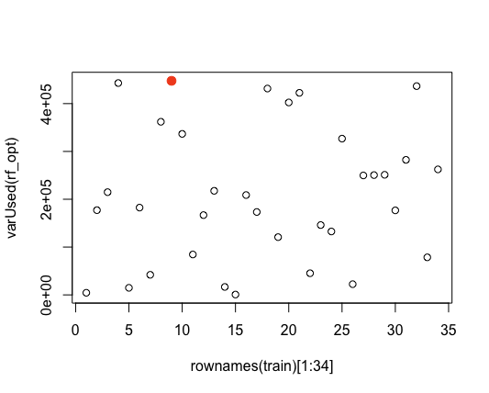

Variable 9 -- CityIdentifier

KNN

K=5

Accuracy:

test.Y

pred 0 1

0 25618 23390

1 24401 26591

[1] 0.52209